How to add system call to the linux OS Kernel

"Tomodachi Team"

**Team Names:**

-Salma Ahmed

-Nada Nady

**CPU Cores:**

**In our system we used 2 cores.**

A CPU core is a [CPU’s](https://www.tomshardware.com/reviews/cpu-buying-guide,5643.html) processor. In the old days, every processor had just one core that could focus on one task at a time. Today, [CPUs](https://www.tomshardware.com/reviews/best-cpus,3986.html) have been two and 18 cores, each of which can work on a different task. As you can see in our [CPU Benchmarks](https://www.tomshardware.com/reviews/cpu-hierarchy,4312.html) Hierarchy, that can have a huge impact on performance.

A core can work on one task, while another core works a different task, so the more cores a CPU has, the [more efficient it is](https://www.tomshardware.com/reviews/best-performance-cpus,5683.html).

Most processors can use a process called [**simultaneous multithreading**](https://www.tomshardware.com/reviews/simultaneous-multithreading-definition,5762.html)or, if it’s an Intel processor, [**Hyper-threading**](https://www.tomshardware.com/reviews/hyper-threading-intel-definition,5746.html) (the two terms mean the same thing) to split a core into virtual cores, which are called [**threads**](https://www.tomshardware.com/reviews/cpu-computing-thread-definition,5765.html). For example, [AMD CPUs](https://www.tomshardware.com/picturestory/846-amd-beats-intel-cpus.html)with four cores use simultaneous multithreading to provide eight threads, and most Intel CPUs with two cores use Hyper-threading to provide four threads.

**Memory Capacity:**

Our device is 4 GB.

Memory capacity is the amount of memory that can be used for an electronic device such as a computer, laptop, smartphone or other smart device. Every hardware device or computer has a minimum and maximum amount of memory. The performance of a device and the efficiency of its input/output operations is dependent on memory capacity.

The memory capacity of a device is commonly expressed in bytes, kilobytes, megabytes, gigabytes or terabytes. A device's memory capacity can be obtained from either the operating system or motherboard.

The memory capacity of a device depends on many factors such as the number of available address registers in the CPU**. As for a 64-bit computer, the memory capacity is unlimited Like our device.** Operating systems also influence memory capacity

**Kernel Version:**

**Our version is linux/4.8.8**

A kernel is the lowest level of easily replaceable software that interfaces with the hardware in your computer. It is responsible for interfacing all of your applications that are running in “user mode” down to the physical hardware, and allowing processes, known as servers, to get information from each other using inter-process communication (IPC).

kernel is the core program of the operating system. It starts just right after the bootloader, and it manages all the available hardware resources, providing an abstraction layer for what is known as application programs. The kernel serves as the bridge between your computer hardware and the software you wish to run. It talks to the hardware via the drivers that are included in the kernel.

**steps of adding the system call in linux kernel:**

1. Download the source code of the latest stable version of the Linux kernel to the home folder.
2. Unpack the tarball to the home folder.
3. Change working directory to the root directory of the recently unpacked source code.
4. Create the home directory of the system call.
5. Create a C file for the system call.
6. Create a Makefile for the system call.
7. Add the home directory of system call to the main Makefile of the kernel.  
   - Search for core-y. In the second result, you will see a series of directories. Kernel/ certs/ mm/ fs/ ipc/ security/ crypto/ block/
8. Add a corresponding function prototype for system call to the header file of system calls.
9. Add system call to the kernel's system call table.
10. install the new kernel and prepare the operating system to boot into it.
11. Configure the kernel.
12. Find out how many logical cores we have.
13. Compile the kernel's source code.
14. Prepare the installer of the kernel.
15. Install the kernel.
16. Update the bootloader of the operating system with the new kernel.
17. Change working directory to your home directory.
18. Create a C file to generate a report of the success or failure of system call.
19. Compile the C file that we created.
20. Run the C file we compiled.
21. Check the last line of the dmesg output.

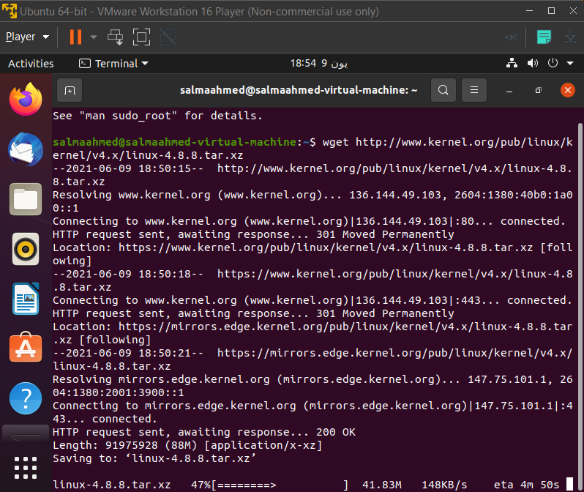

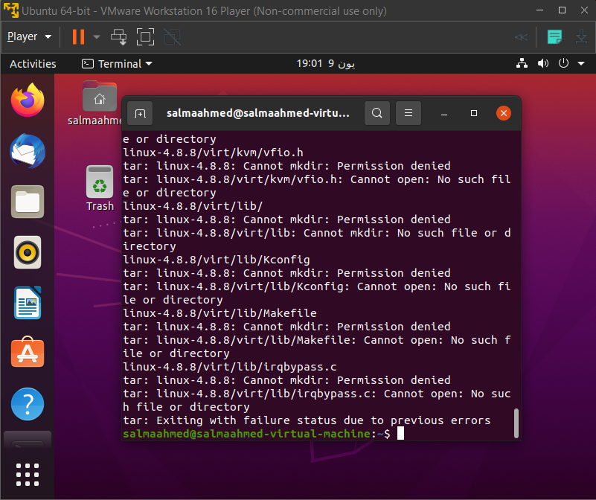

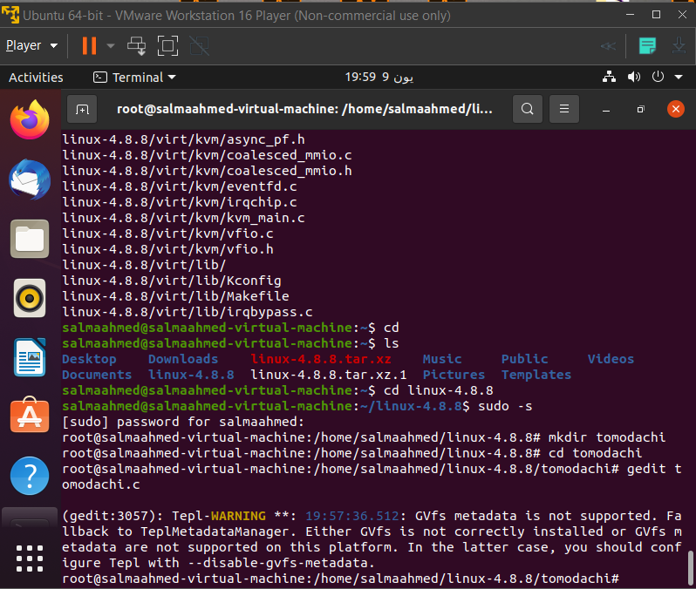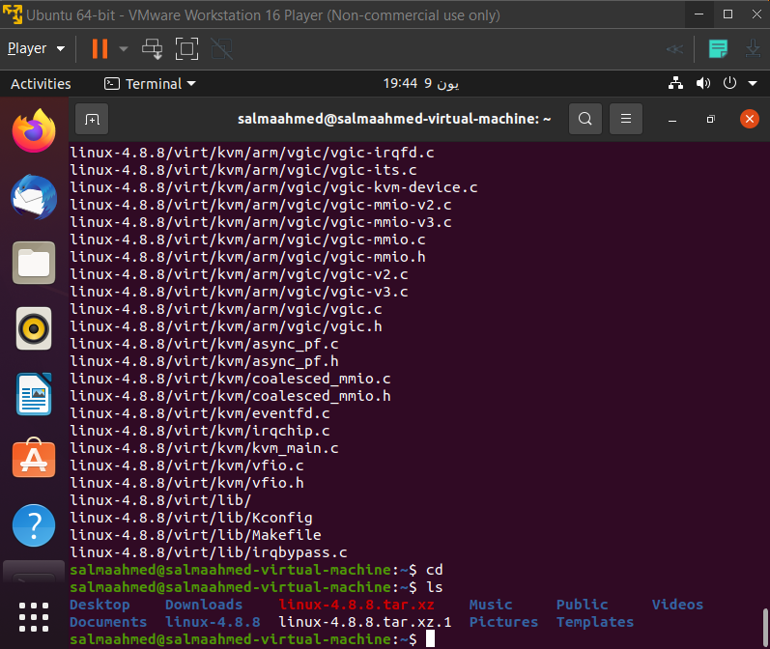

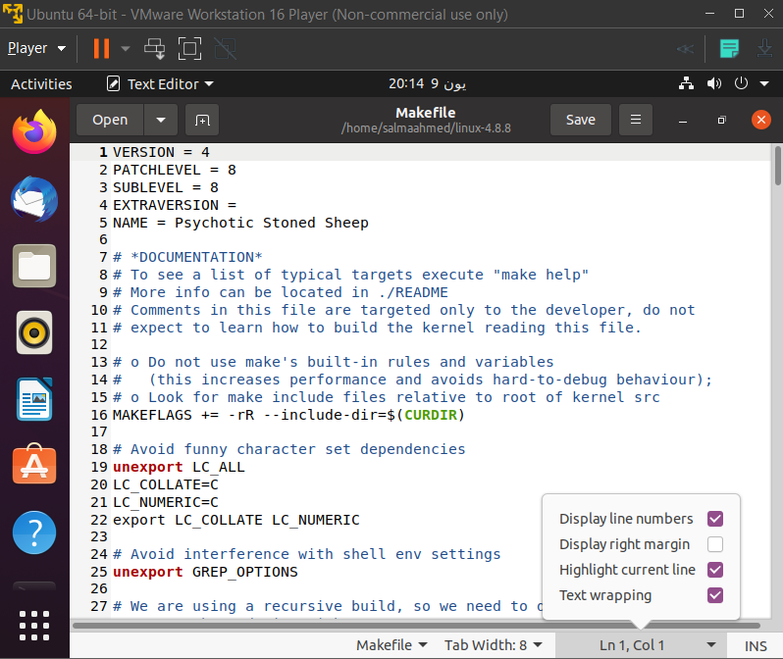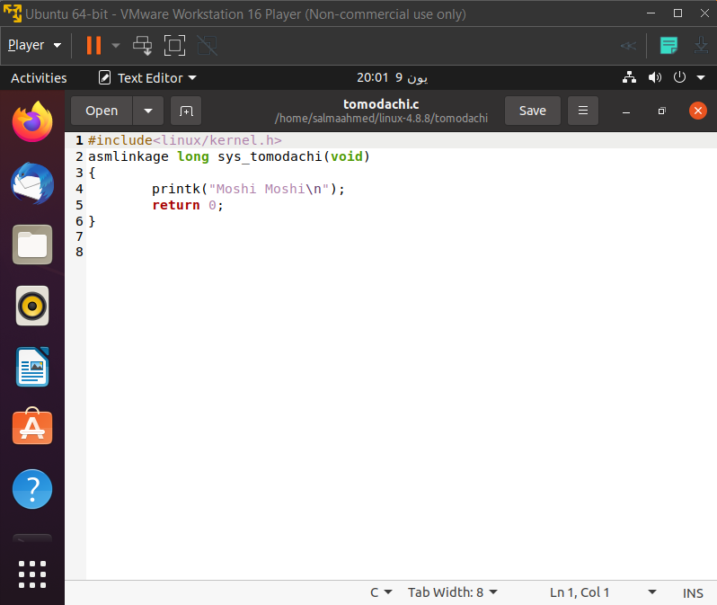

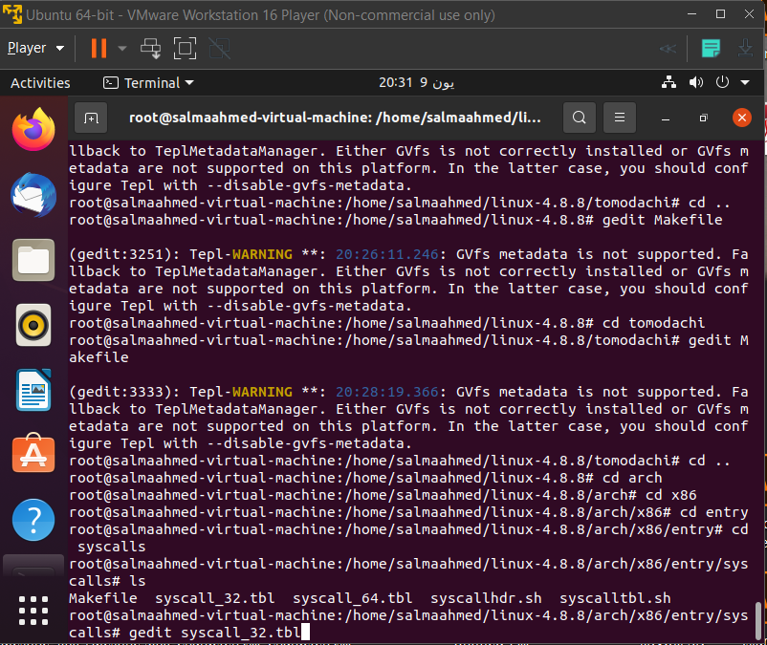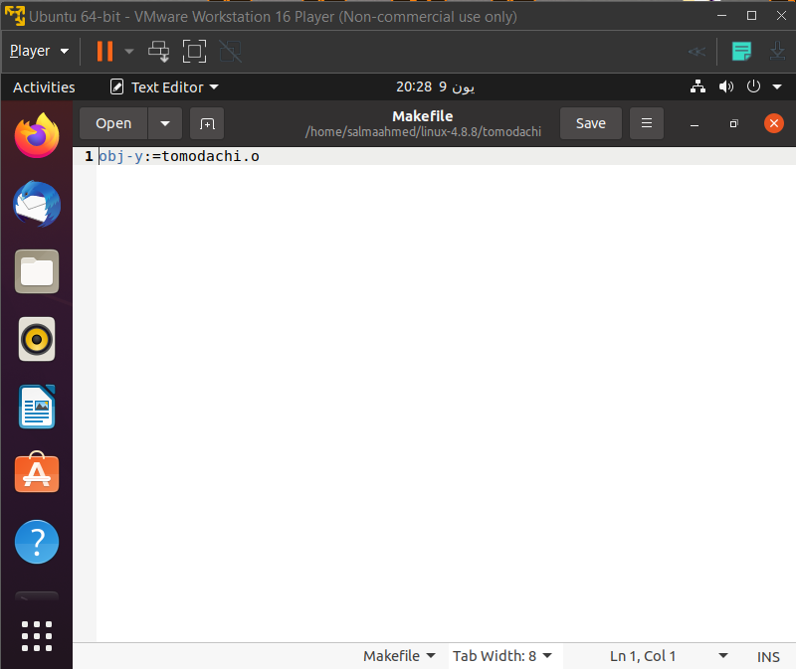

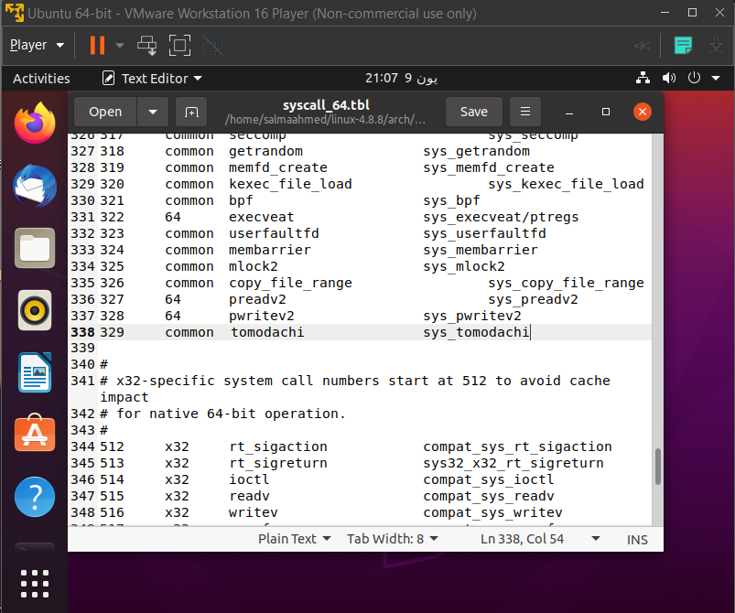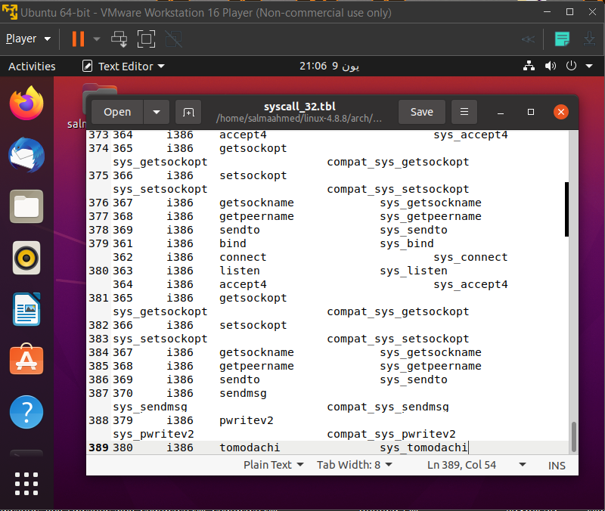

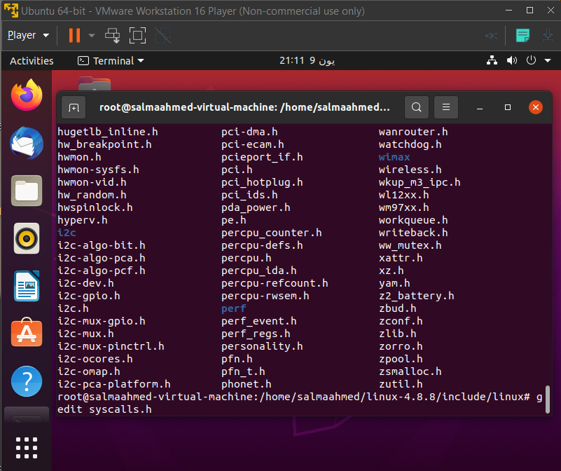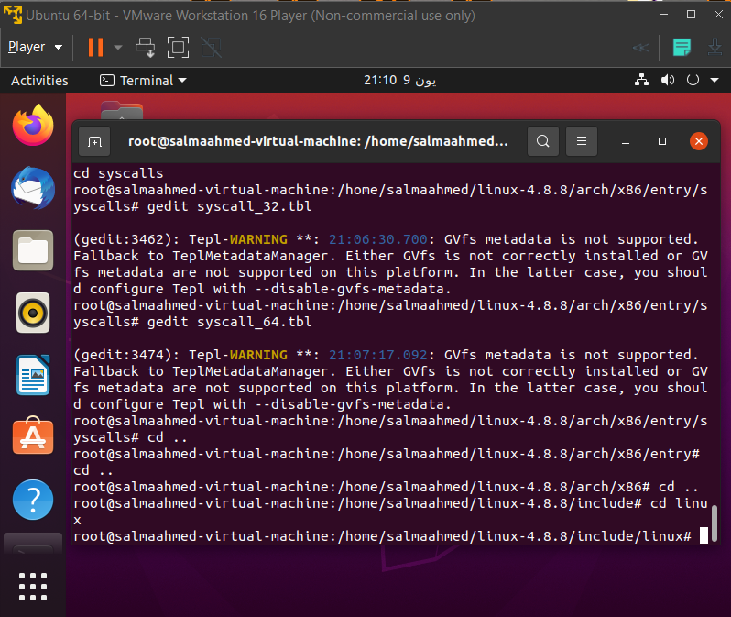

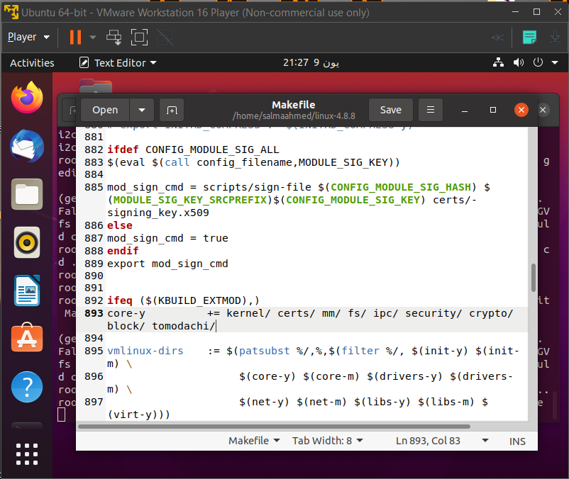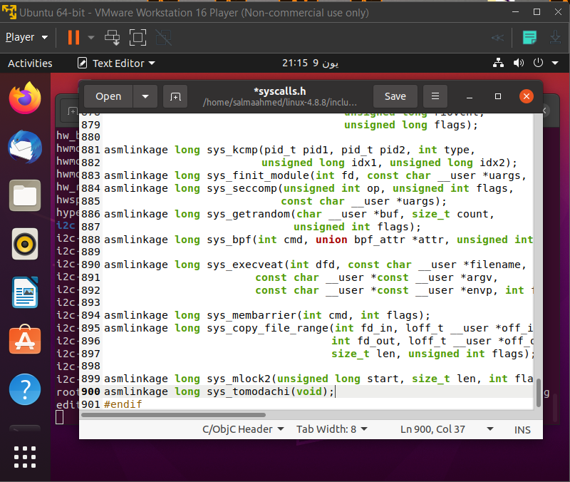

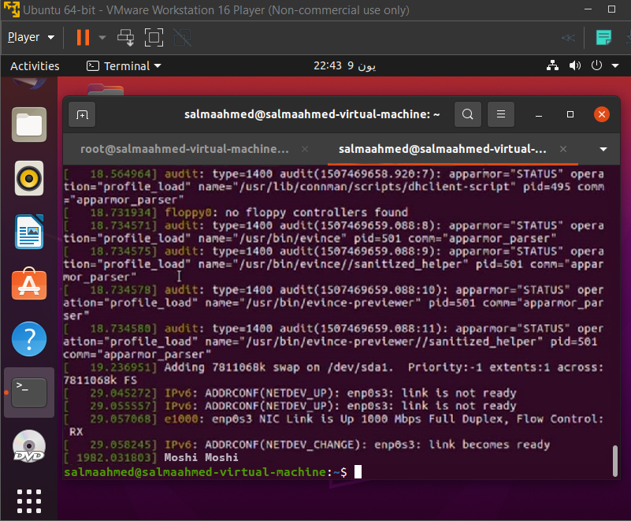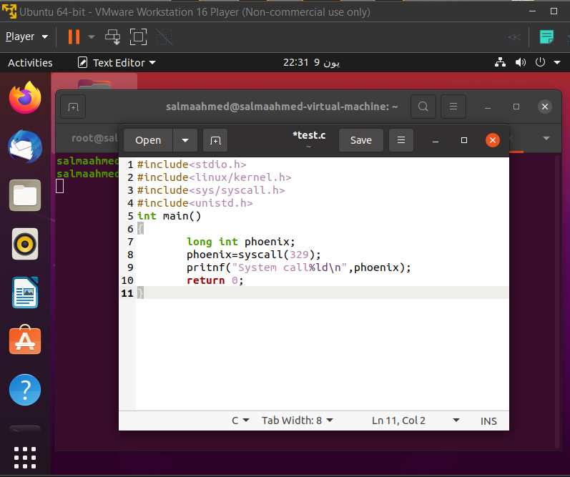

**References:**

[**https://www.tomshardware.com/news/cpu-core-definition,37658.html**](https://www.tomshardware.com/news/cpu-core-definition,37658.html)

[**https://www.hp.com/us-en/shop/tech-takes/cpu-cores-how-many-do-i-need**](https://www.hp.com/us-en/shop/tech-takes/cpu-cores-how-many-do-i-need)

[**https://www.computerhope.com/jargon/r/ram.htm**](https://www.computerhope.com/jargon/r/ram.htm)

[**https://www.techopedia.com/definition/8297/memory-capacity#:~:text=Memory%20capacity%20is%20the%20amount,and%20maximum%20amount%20of%20memory**](https://www.techopedia.com/definition/8297/memory-capacity#:~:text=Memory%20capacity%20is%20the%20amount,and%20maximum%20amount%20of%20memory)**.**

[**https://www.howtogeek.com/howto/31632/what-is-the-linux-kernel-and-what-does-it-do/**](https://www.howtogeek.com/howto/31632/what-is-the-linux-kernel-and-what-does-it-do/)